**SALE HAS BEEN EXTENDED!!!**

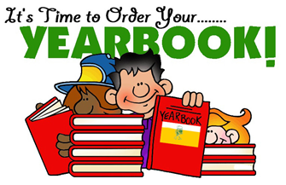

**WHAT:** Yearbooks are on sale NOW!

**WHERE:** All sales are to be made online at [www.ybpay.lifetouch.com](http://www.ybpay.lifetouch.com) using ID code 1745621.

(Please do not send any orders into school)

**WHEN:** Please have all orders submitted online by **Friday, May 7th!**

*If financial need prevents your child from ordering a yearbook, please contact Principal [Alex Audette](mailto:alexaudette@wbschools.com).

Thank you for supporting the Major Edwards Yearbook. It will be a great way for students to remember this crazy school year!