WEST BOYLSTON IS IN IT TO END IT 

**Raffle Basket Donation**

Friday, May 6th, 2016

Gates Open 4:30

Opening Ceremony 5pm

Walk 5pm -9: 30pm

Dear Potential Donor,

Since the Spring of 2012, West Boylston Middle/High School has run the WB Is in it to END it event. It began with the Class of 2012. During March of their senior year, the mother of a member of the class passed away from cancer. She was another in a long line of parents lost in our small school community. Several students joined together create a positive experience from their collective grief. That May this student-created, student-run event, modeled after the American Cancer Society’s, Relay for Life, was born.

WB Is in it to END It features entertainment, games for kids, food vendors, a basket raffle and teams of twelve or more walking a relay for several hours. Money raised through team registration, local sponsors, basket sponsors and an entrance fee goes into the WB Is in it to END It fund. After each event, profits are split between a donation to the American Cancer Society and the WB Is in it to END It scholarships for graduating seniors who lost a parent during their school years.

Our goal is to have our community come together for fun, reflection and purpose, all in the name of benefiting students and contributing to the fight to end cancer.

This year is our fifth event. We are reaching out to our community to consider donation a basket to our Basket Raffle.

Thank you for taking the time to consider helping us.

Ms. Debora J. Goodwill, WB Is in it to END It Adviser

Ms. Marissa Hayes, Student Coordinator, Class of 2016

Ms. Toni Pinkham, Student Coordinator, Class of 2016

WEST BOYLSTON IS IN IT TO END IT 

Basket Donation Form

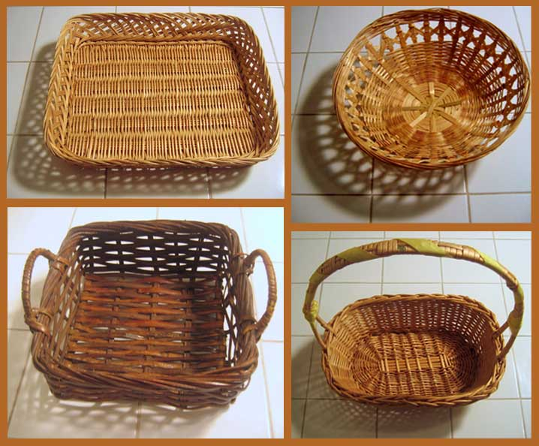

**Baskets in the past have included themes such as:**

Summer fun, Around Town-gift certificates, Movies,Cooking, Educational games, Gardening, Scratch Tickets, Barnes and noble, Art theme, W.B. spirit and many more !

We appreciate your having the basket wrapped or enclosed to protect the contents. Thank you.

**Use your creativity!**

Business/Group: ___________________________________

Basket Theme: _____________________________________

Contact Person’s Name: ______________________________

Contact Person’s Email or Phone #: ______________________  
________________________________________________

Please attach this form to your basket. Thank you!

E-mail **deboragoodwill@wbschools.com** if you have questions!

Baskets may be dropped off at the main office. Our deadline is April 29, 2016